International 6-day timber framing course on 28th of July – 2nd of August 2025

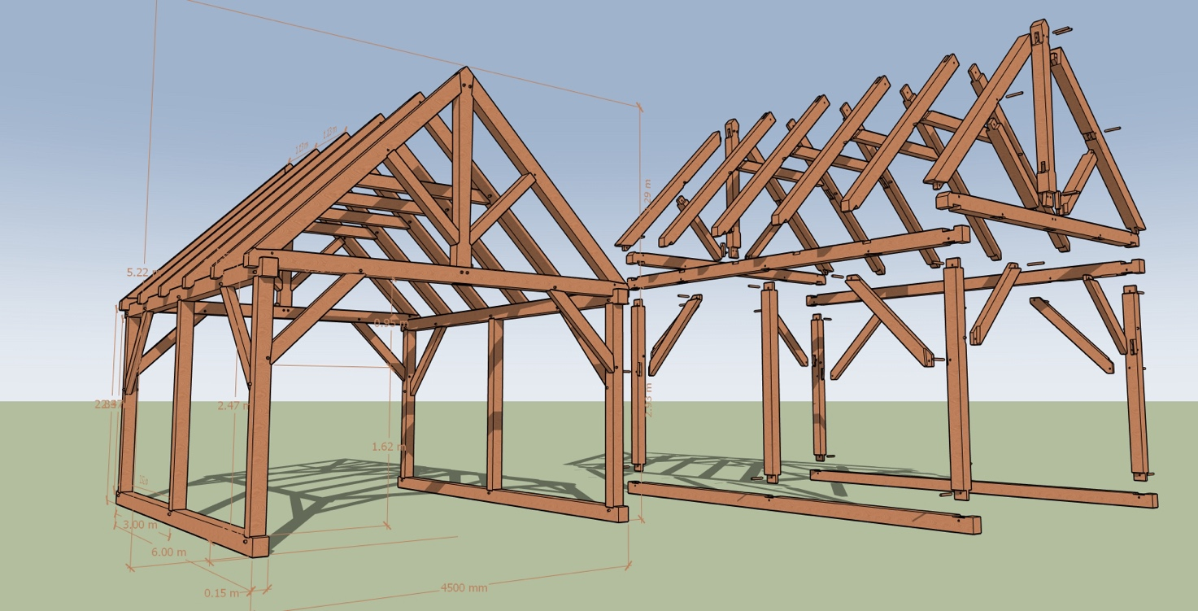

“Timber framing is a distinctive style of building construction in which heavy timbers frame the structure instead of more slender dimensional lumber. One of the most defining elements of a timber frame is its unique joinery. Heavy timber is joined together via mortises and tenons, then secured with wooden pegs.”
Timber Framers Guild

Our international 6-day timber framing course, held in a workshop and outdoor environment in Vuokatti, the North-East of Finland, provides you with the skills and tools to help you complete your own timber wood projects.

We are using both hand and power tools to complete at the end of the course, a timber framed 4 m x 6 m building to which each student have contributed. The building can be used for example as an outdoor kitchen, a garden house, etc. The frame of the building will be raised on the last day of the course.

Led by four teachers’ team, with years of expertise in various aspects of woodwork, course offers for up to 12 people and starts with the aim of equipping every person who attends with traditional woodworking skills. The course will be held in English and Finnish.

6-day course is a great way to be creative in a completely different way, combining design and logistics with hand-on crafting. This is a great course to enjoy as a couple, with a group or friends or as an investment in some quality me-time.

Additional information: Three meals per day during weekdays, and two meals on the last day. There will also be a tar burning excursion, a traditional Finnish smoke sauna on a lakeside and a special dinner.

Accommodation: Four persons cabin equipped with kitchen, electric sauna and washing machine. The cabins are close to the local lake. Full lodging is provided from Sunday 27th of July evening to Saturday 2nd of August morning.

Course site: The course will be held in the premises of Carpenter’s Shop Vaaksa. It is located in Vuokatti, in the North-East of Finland. The nearest airport and train station are in Kajaani, about 35 km’s from the course site.

Cost: 1900 EUR (includes everything on site: course, accommodation, all meals, and organized field trips, and transportation from Kajaani airport / train station to site and back). Students are responsible for their own travelling costs, travel insurances, and extra-curricular costs. Please note that half (a 50% non-refundable deposit) of the course fee is paid when applying for the course (PayPal) to secure your place. The remaining balance (50 %) of your booking must be paid 30 days before the start of the course by PayPal or cash on arrival.

Other information: If you cancel the participation 60 days before the start of the course, 50 % of the deposit is returned. If you cancel later, no return of the deposit is given.

Sign up: https://www.vaaksa.com/fi/verkkokauppa/international-6-day-timber-framing-course-on-28th-of-july-2nd-of-august-2025

More information: info@vaaksa.com

